**Sprint Schedule**

**COMP3000**

**Computing Project**

**2022/2023**

**Project Title**

ChessAI – A Chess Practice Tool

**Project Lead Developer / Manager**

Callum Organ

**Project Supervisor**

Lingfen Sun

**Links**

Source code:<https://github.com/ORG4N/ChessAI>

Kanban board: <https://trello.com/b/TubtD2KW/chessai>

|  |  |  |  |
| --- | --- | --- | --- |
| Document Revision History | | | |
| **Date** | **Ver.** | **Description** | **Changed by** |
| 29/01/2022 | 1 | Document created. | Callum Organ |

**Document Overview**

Within sprints 3 and 5 it was noted that a major complication within the project relates to low productivity within the time approaching and succeeding assignments and their deadlines. The issue arising from this is that sprint items are overplanned and little work is done, or none at all, and the unfinished jobs are pushed to the next sprint. This results in the project suffering from being ‘behind’ schedule.

This overall objective of this document is to map the sprints within the second semester (from sprint 6 onwards) and justify breaks in between sprints as well as to highlight important deadlines to be aware of.

First Semester 3

Sprint Roadmap 3

Challenges 3

Second Semester 4

Sprint Roadmap 4

Improvements in Scheduling 4

Final Roadmap 5

Note: will be finished upon completion of semester two roadmap 5

Conclusions 6

First Semester

At the time of creating this document, the first semester has just ended and therefore this section of the report highlights the issues encountered with project management in semester one.

## Sprint Roadmap

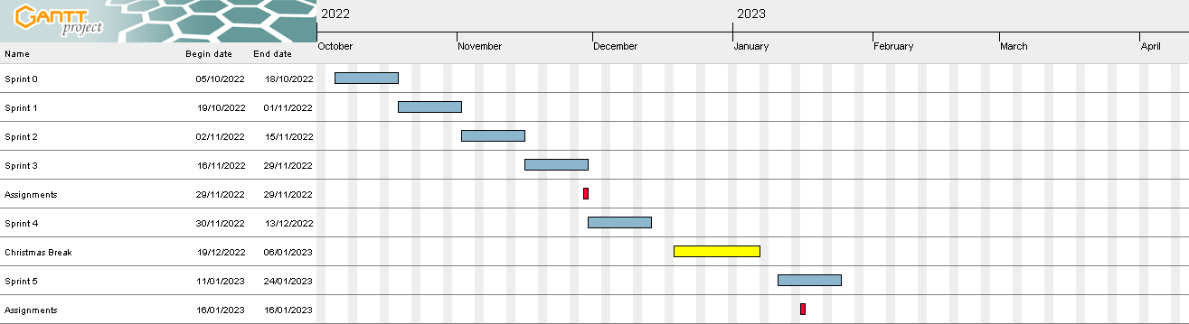

This figure shows a roadmap for all sprints that occurred within semester one, where:

* Blue boxes represent sprints.
* Red boxes represent assignment deadlines.
* Yellow boxes represent vacations/breaks.

## Challenges

As seen within the figure above, some sprints overlap with assignment deadlines (such as, sprints #3 and #5). The complications that this overlap causes is that assignments are a higher priority than a sprint and must be urgently worked towards completing. Therefore, as the focus of the weeks preceding deadlines is the assignment for that specific deadline, the jobs set to be completed within the conflicting sprints don’t end up being worked towards.

This issue sprouted from a lack of foresight when setting sprint dates – mainly because the proposed Gantt chart within the *Project Initiation Document* is of low quality and does not highlight important dates. Also, the lack of a pre-planned sprint schedule/overview document resulted in I, the project lead, just creating sprints linearly, one after the other.

Overall, to ensure that these problems do not re-surface within the second semester, a sprint roadmap will be made prior, similar to the above one, wherein assignment deadlines and vacations are highlighted. However, the roadmap for semester two will solve the conflict issues in semester one’s roadmap by removing the overlap and adding breaks, where needed, between sprints.

Second Semester

As of creating this document, the second semester has not started yet, and in line with the previously outlined challenges within semester one, I, the project lead, will try to solve those issues by preplanning the sprints within semester two around assignment deadlines within the semester two modules.

## Sprint Roadmap

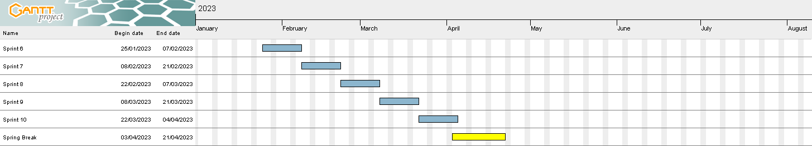

This figure shows a roadmap for all sprints that occurred within semester two, where:

* Blue boxes represent sprints.
* Red boxes represent assignment deadlines.
* Yellow boxes represent vacations/breaks.

**Note:** this roadmap is currently unfinished due to assignment deadlines not being known, so sprints have been planned up until the earliest point in which assignments deadlines will be set. This document will be revisited upon release of assignments.

## Improvements in Scheduling

**Note:** see previous notes within roadmap – currently unable to justify improvements – will be amended upon assignment release

Final Roadmap

Note: will be finished upon completion of semester two roadmap

# Conclusions

Note: conclusions will be made to discuss the changes between semester one and two, once semester two roadmap is finalised and overall roadmap has been completed.